Authors:

* Adonis Macris: ST10122275
* Alexis Messinezis: ST10121042
* Lucas Mouskides: ST10121219
* Mitesh Bhula: ST10122364

Assignment Type: POE Part 1

Year: 3rd Year

Campus: Sandton

Module Code: OPSC7312

Module Name: Open-Source Coding

Examiner Name: Samuel Chikasha

OPSC POE PART 1

Table of Contents

Introduction 4

Existing Application 1 4

Monuments.guide – Travel Guide 4

Innovative features of the Monuments.guide app 5

How we think the Monuments.guide application was developed 6

Application screenshots 7

Existing Application 2 11

World Famous Landmarks Travel & Explore Guide 11

Innovative features of World Famous Landmarks Travel & Explore Guide app 12

How we think the World Famous Landmarks Travel & Explore Guide app was developed 12

Application Screenshots 13

Existing Application 3 20

Spotted by Locals 20

Innovative features of the Spotted by Locals app 21

How do we think the Spotted by local’s app was developed? 21

Application Screenshots 22

Research application comparison infographic 27

Conclusion 28

Part 2 – Planning and Design 29

Introduction 29

Overview of application and features 29

Innovative features 30

Requirements 31

User Interface Design 32

Login Screen 33

Signup Screen 34

Main Screen 35

Menu Clicked 36

Favourite Landmark Clicked 37

Preferred Landmark Clicked 38

Selected Landmark 39

Route to Landmark 40

Database Data 41

Data that will be stored in the database 41

Project Plan deadlines and milestones 43

Conclusion 45

Reference List 46

# Introduction

As a group, we have been tasked to create an application that can be used to explore local landmarks and serve as a guide to each landmark. The application will aid users in their quest to explore landmarks such as monuments, statues, and parks. The application will provide the shortest possible route to reach each landmark using GPS location tracking and an interactive map. The application will be available for download on the Google Play Store. The following apps were researched as part of the planning and research phase: Monuments.guide – Travel Guide, World Famous Landmarks Travel & Explore Guide, and Spotted by Locals. These applications have many innovative features that we will use as inspiration for the development of our application.

# Existing Application 1

## Monuments.guide – Travel Guide

Monuments.guide is a travel guide developed by Monuments and is available on the Google Play Store. This application features a guide that is used to view landmarks around the United States of America. The application is developed as an easy-to-use travel guide that identifies any landmarks of interest based on a user search and their current location. The application pinpoints each landmark on a map with the address and an option to add the landmark to your favourites or share it with friends and family on Facebook and other applications.

|  |  |
| --- | --- |
| Strengths | Weaknesses |
| * Lists more than 60 000 landmarks within the USA * Allows for suggested landmarks based on user location * Provides estimated distance to landmark from user location * Landmark share feature | * Does not provide any details regarding the landmarks listed * Inaccurate search function * Does not support languages other than English * Does not cater to landmarks outside of the USA |

# Innovative features of the Monuments.guide app

The Monuments.guide application has features that we may implement. These include allowing users to view landmarks close to their current location and the quickest route that leads to the landmark. The use of a search and sort function is required and will serve as a non-functional requirement. The share feature is a good addition to the application and will allow users to share landmarks with their friends and families. The weaknesses of the monuments.guide application included an inaccurate search function and no details regarding the listed landmarks. We would therefore like to create a functional search feature. The monuments.guide applications do not give users details regarding the landmark and its importance; we would like to provide users with a small write-up regarding the significance of each landmark. The strengths of the monument.guides application includes more than 60 000 landmarks, suggestions based on location, and distance to the landmark. We would like to implement these features and further include the fastest route to reach the landmark. We will make use of a Realtime database provided by the Google Firebase platform to store user login information for the personalisation of the application. We aim to develop an application that meets these requirements whilst making the application fun and easy to use for registered users of all ages and skill levels.

# How we think the Monuments.guide application was developed

The monuments.guide application may make use of the Google Maps web service (Google Maps Platform | Google Developers, 2022) to provide users with monuments nearby to their current location, popular monuments, and the exact location of the monument. The application may further use the Google Places Application Programming Interface (API) (Overview | Places API | Google Developers, 2022) this would allow the application to gain access to searching for nearby places based on the user’s current location, information regarding the landmark and recent images of the monument.

We would consider using both the Google Maps and Google Places web services in our application and any other web services that are customised for South Africa such as MapIT (Developers | MapIT, 2022). The MapIT API will give access to data from more than 50 countries in Africa and more than 70 spoken languages (Developers | MapIT, 2022).

# Application screenshots

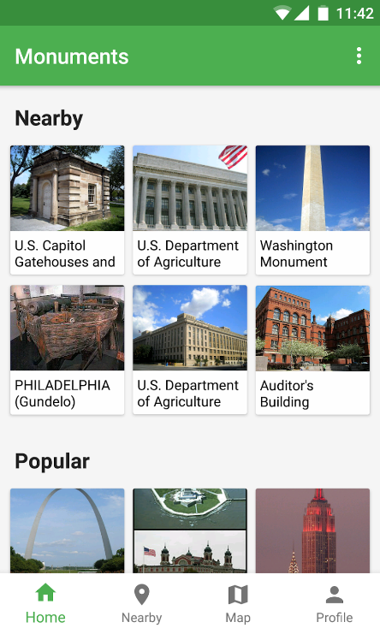

Figure 1: Monuments.guide home page (Google Play Store, 2022)

Figure 1 depicts the homepage of the application. The home page is used to display monuments that are nearby to the user’s current location. The home page also contains a list of popular landmarks within the USA. The bottom of every page has navigation that toggles between the “Home”, “Nearby”, “Map” and “Profile” pages.

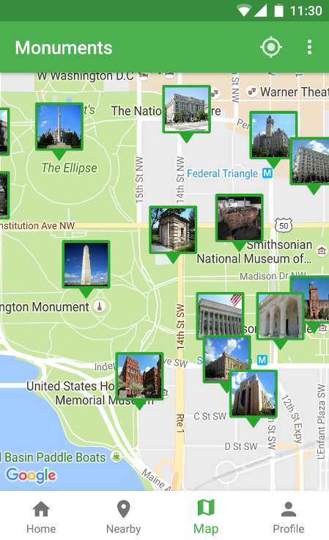

Figure 2: Monuments.guide Map page (Google Play Store, 2022)

Figure 2 shows all the available landmarks for that area along with an image of the landmark. The map is powered by Google for details such as address and the distance from the user to the landmark.

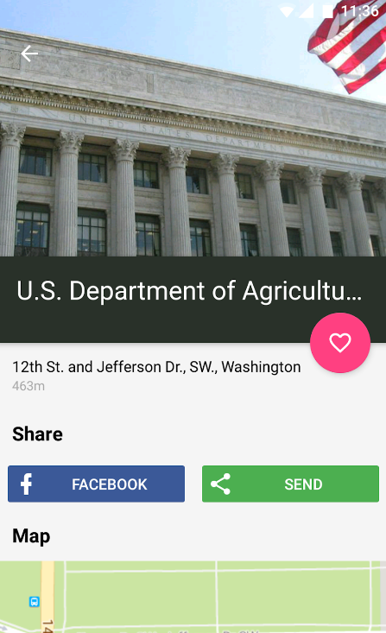

Figure 3: Screen providing details of a landmark (Google Play Store, 2022)

This page provides users with an image of the landmark and its name. The pink heart allows users to favourite the landmark. The landmark is also able to be shared on Facebook and other platforms through the send button. A map also includes showing the exact location of the landmark and the distance between the user and the landmark.

Figure 4:Monuments.guide Nearby page (Google Play Store, 2022)

Figure 4 refers to a list of nearby monuments based on the user’s current location. An image, the name, address, and distance between the user and the landmark are provided to users.

# Existing Application 2

## World Famous Landmarks Travel & Explore Guide

World Famous Landmarks Travel & Explore Guide is an application developed by Edutainment Ventures- making Games People Play and is available for download on the Google Play Store (Play.Google.com, 2022) The application serves as an all-in-one guide to various cities and countries around the world. The application aims to assist tourists in exploring landmarks in any country they visit. Each landmark is categorised into 3 categories namely historical, aesthetic, and cultural (Play.Google.com, 2022). The application further provides users with a description of each landmark and a summary of the history of the city and country in which the landmark is situated. Landmarks can be sorted according to popularity; a search feature has also been developed and landmarks can also be listed alphabetically.

|  |  |
| --- | --- |
| Strengths | Weaknesses |
| * Lists landmarks in many countries * Allows for suggested landmarks based on user location * Allows users to create customised routes and itineraries to include all landmarks they wish to visit in a city. * Landmark share feature * Provides users with the importance of each landmark and the most appropriate time to visit * Using Google Street View allows users to view and understand the area around a landmark. | * Contains in-app purchases for additional features * Does not support languages other than English * The design and overall visual appeal of the application aren’t attractive. |

# Innovative features of World Famous Landmarks Travel & Explore Guide app

The World Famous Landmarks Travel & Explore Guide has many innovative features which we may wish to implement. The application caters to many countries globally which is something we could explore in the development of our application. Users being able to create customised routes based on their choices of landmarks they would like to visit is an advanced feature we would explore. This would be useful in a situation where a user would like to visit a landmark but has not had lunch and sees a nearby restaurant to which they would like to have lunch before or after visiting the landmark and will need directions. The share feature is something we consider implementing as this will allow a landmark to be shared amongst family and friends who also be interested in visiting the same or similar landmarks. The use of Google Street View (Google.com, 2022) is an impressive feature that is quite useful as it allows users to view the surroundings of the landmark as if they were standing in front of a landmark and is useful when visiting a new place for the first time. The design of the application is quite boring and mundane, we would like to create an application that is easy to use whilst still being visually appealing. The application also provides a form for users to suggest additional features and provides feedback that allows developers to continuously improve the application (Play.Google.com, 2022). We may further wish to implement the Google Street View API and support for multiple spoken languages as South Africa has a range of spoken languages we wish to cater to if possible.

# How we think the World Famous Landmarks Travel & Explore Guide app was developed

This application makes use of the Google Maps web service (Google Maps Platform | Google Developers, 2022) to identify landmarks. The Maps web service is used to identify all landmarks that are nearby to the user’s current location. The application also makes use of the Google Street View API (Google.com, 2022) which provides users with views of the landmark from the street and any other buildings surrounding the landmark. The application further makes use of a web service to identify landmarks in each listed country and city within the application.

# Application Screenshots

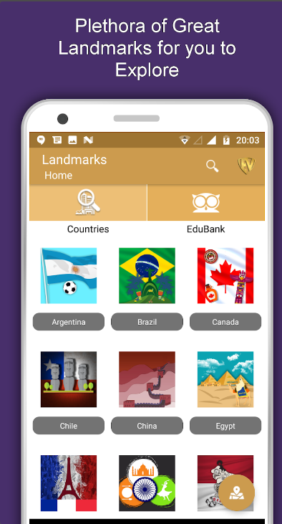

Figure 5: Application home page (play.google.com, 2022)

World Famous Landmarks & Travel Guide homepage. Each country is represented by the colours of its respective flags. The search function has been implemented to allow users to search for a country. The “EduBank” is the application's “favourite list” in which users can add a particular country, city, or landmark to their list of favourites.

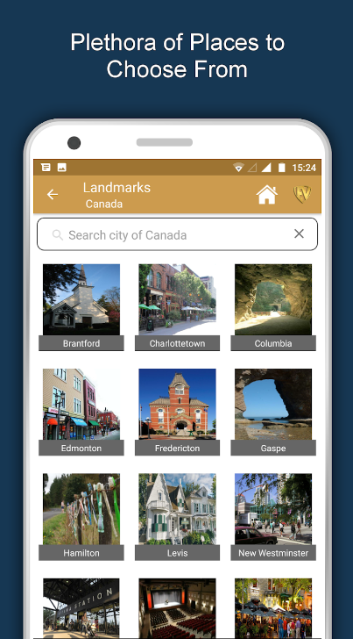

Figure 6: The landmark page (Play.Google.com, 2022)

This page is the landmarks page in which the user selected a country of Canada, and the application returned all the cities within Canada that have landmarks. This allows users to view a list of landmarks within the current city they are in or plan to visit. The search bar allows users to search for a particular city with the country previously chosen.

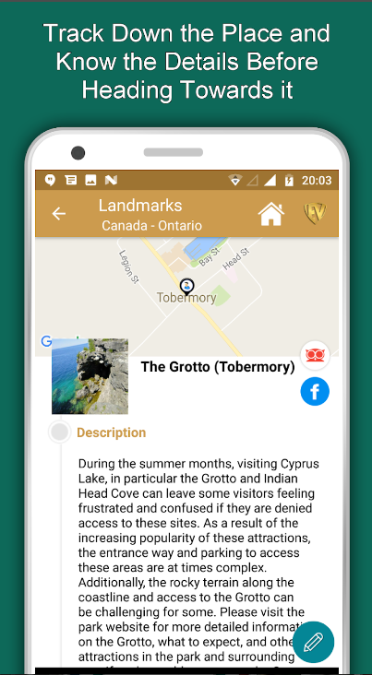

Figure 7: Example of a landmark (Play.Google.com, 2022)

Figure 7 refers to the landmarks page which provides the users with the landmark name and description, an image of the landmark, a Facebook share button, a small map of where the landmark is situated, and an edit pencil button which allow users to edit the landmark description if they wish to.

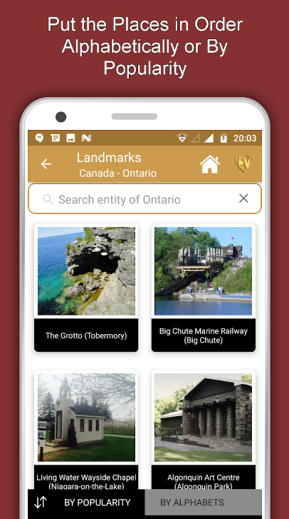

Figure 8: Sorting landmarks based on popularity or alphabetically (Play.Google.com, 2022)

Figure 8 shows how users can filter through landmarks based in the city of Ontario in Canada based on the popularity of the landmark or scroll through a list sorted alphabetically.

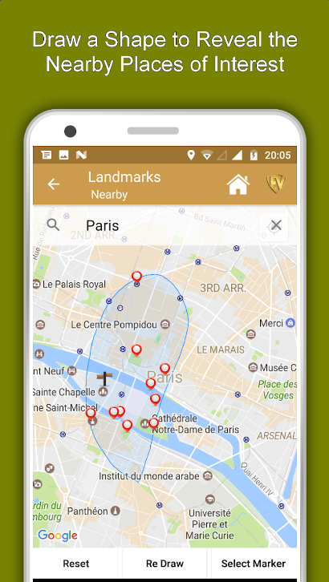

Figure 9: Places of interest within a small area (Play.Google.com, 2022)

This figure refers to how users will be able to select a small area on the map drawn on their device and all places of interest within the area will be returned to the user.

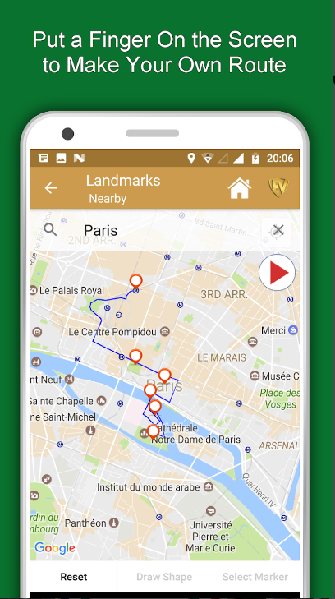

Figure 10: User-created route (Play.Google.com, 2022)

This screen allows users to select a custom route they would like to follow to see each landmark and any other places of interest. The red triangle button starts the route and directs users to each location.

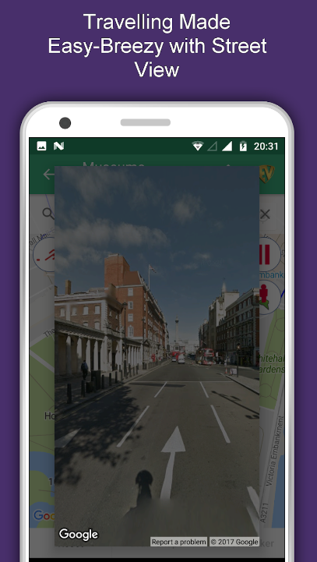

Figure 11: Route view with Street View (Play.Google.com, 2022)

This image refers to the use of Google Street View (Google.com, 2022) to visualise the surroundings of a landmark or the route to a landmark in real life.

# Existing Application 3

## Spotted by Locals

Spotted by locals is an app developed by spotted by locals and available on the Apple and Android stores. (Play.Google.com, 2022) The app serves as a travel guide that allows users to visit landmarks. All travel guides have been hand-picked and written by locals. The application allows you to sort by categories such as Art, culture, monuments, and many more. Spotted by locals is an easy-to-use application that lists landmarks based on your current location or based on a user's search. The user can also favourite the landmark and or share it.

|  |  |
| --- | --- |
| Strengths | Weaknesses |
| * Describes landmarks written by handpicked locals. * Categorised menu of landmarks * Works offline. * Landmark share feature (allows for sharing custom landmarks). | * In-app purchases for each city * Travel guide currently only caters to 82 cities. * The search function works poorly * UI of the map is clustered in landmarks |

# Innovative features of the Spotted by Locals app

Spotted by locals makes use of many innovative features that we will add to our application. Although the application does not cater to many countries, they have managed to create a fluid application that creates a local curation that many landmark applications do not. The application also combats over-tourism by promoting fewer known areas in need of exposure. These locations, although not as popular, still have a rich background that the description of the locals unleashes. It allows the users to get an authentic sense of the places they are visiting. The application also lists all landmarks into different categories that the user can sort by making it easy to sort through the landmarks at any time. One of the greatest features that Spotted by locals makes use of is the ability to download the data and not worry about mobile data whilst travelling. The search feature also allows the user to narrow down and locate certain landmarks that they would like to travel to, however when reading over the reviews and trying it out ourselves we noticed that the search function is not as effective as it could be and agreed to improve on it. When opening that map there were multiple landmarks, so much so that it was hard to read certain street names and locations. We decided that in our application we would like to make it easy to read by either adding opacity to the landmarks when zooming out or categorising them more efficiently.

# How do we think the Spotted by local’s app was developed?

Spotted by local’s app makes use of the Google map web services (Google Maps Platform | Google Developers, 2022) to identify landmarks. The web service makes use of user location and identifies landmarks near the user. It is also possible that the app uses Directions API (Google Maps Platform Documentation | Directions API | Google Developers, 2022) This creates a route from where you are to the destination.

# Application Screenshots

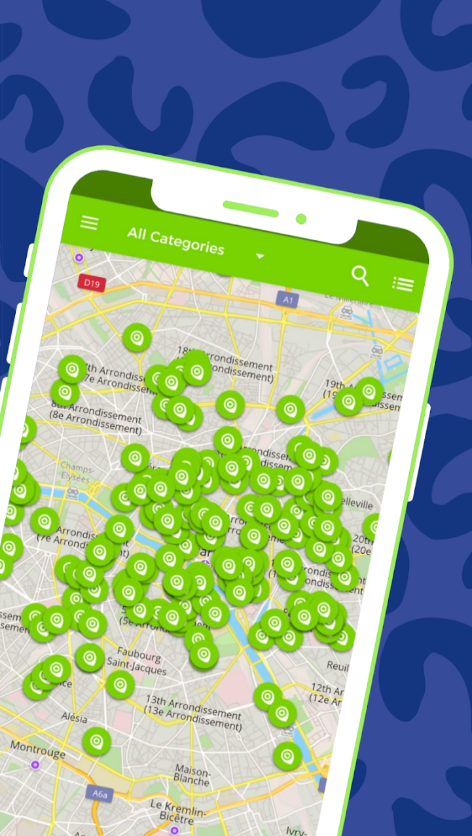

Figure 12: Map view of the screen (Play.Google.com, 2022)

This image shows all the landmarks in a given area on the map near the user. This is the main screen, and it will always initially centralise around the user's location.

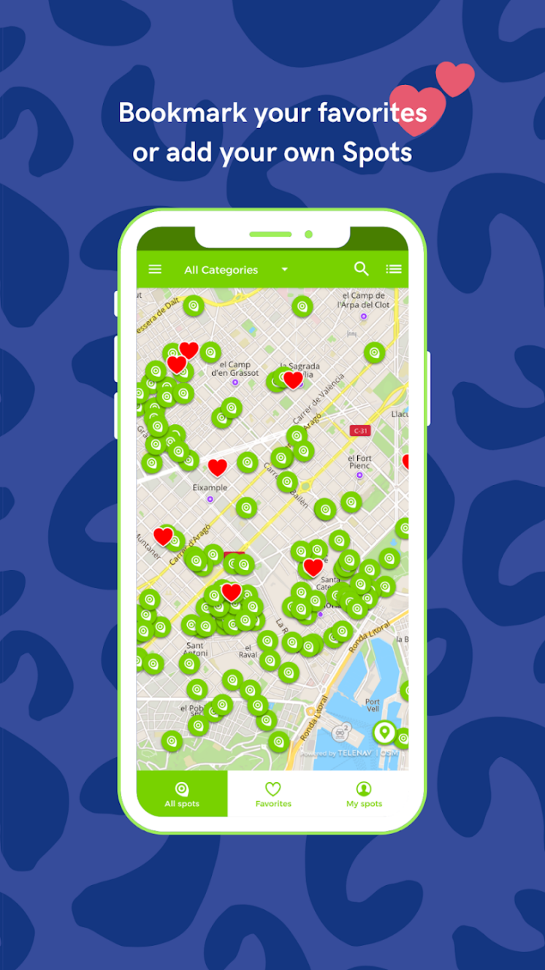

Figure 13: User favourited landmarks (Play.Google.com, 2022)

This figure shows all landmarks around the user as well as all the landmarks the user has been to and has favourited. This allows the user to know where he has been and what landmarks he liked the most.

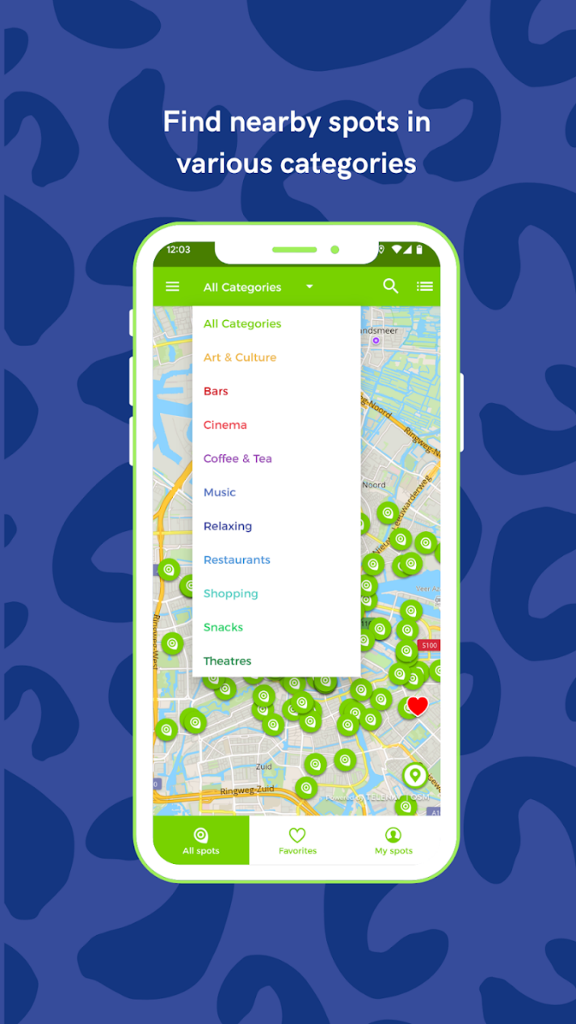

Figure 14: Figure of Categories (Play.Google.com, 2022)

This image shows how the categorise function works. You click the arrow next to all categories and a list shows up whereby selecting multiple categories will show a list of the landmarks of those chosen categories.

Figure 1512: Menu screen (Play.Google.com, 2022)

This is the main page of the app where you can browse through different travel guides. The first tab shows all of the travel guides that have been downloaded and are ready to be used offline. The other tabs are then filtered by continents as we can see in the second tab it is Europe and the middle east and in the third tab, it is North America and so on. On the main page, there is also a search bar where you can narrow your search to find the exact city.

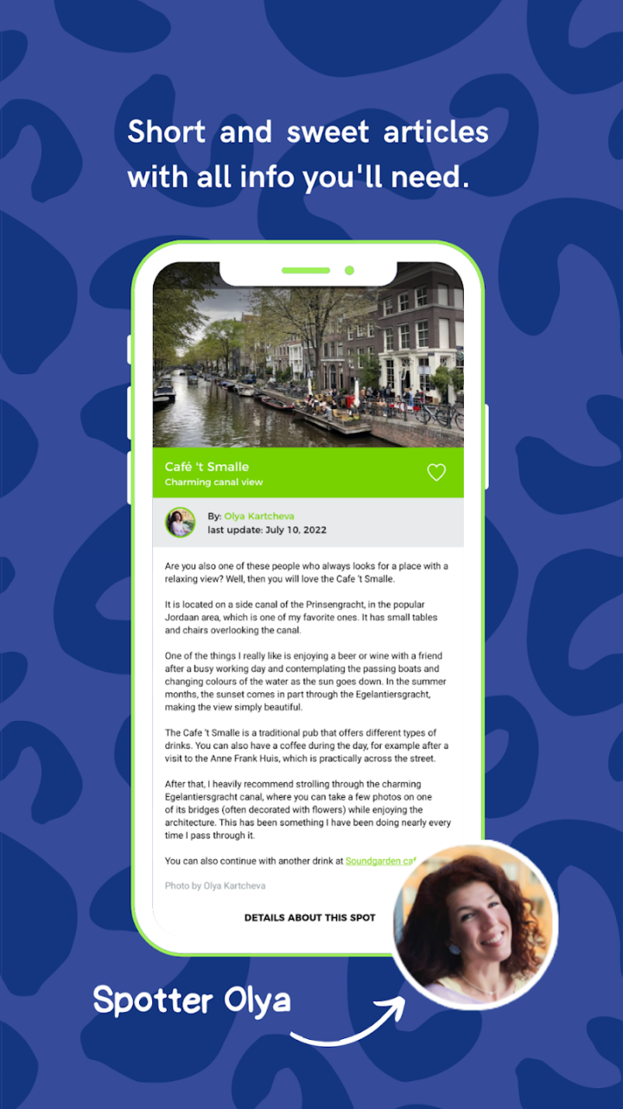

Figure 16: Description of landmark (Play.Google.com, 2022)

In this figure, we see the page that pops up when clicking on a landmark. Here we get to see the history and description of the given location. The local writes about the history, the location, and what he/she thinks you should do after having visited the landmark. On this page, you can also see the name of the local and the last time that local updated their description. In this example you can see at the end the local says “you can continue with another drink at” (link) This link will then take you to another landmark near the current one.

# Research application comparison infographic

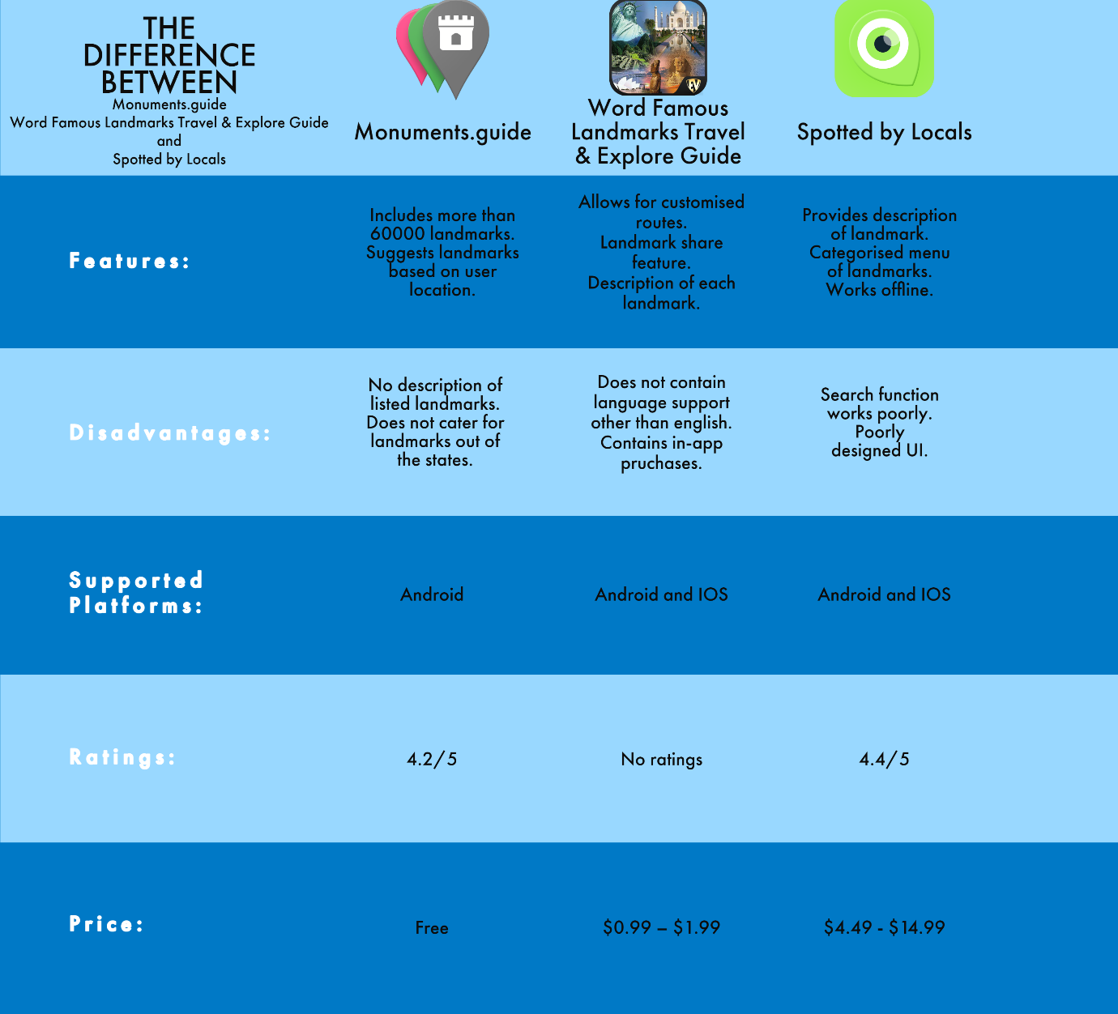

Figure 13: Infographic comparing all 3 research applications

# Conclusion

After conducting the initial research on these three local landmark apps, we agreed on our roadmap and decided to build on the ideas we have gained from each application we have researched. We have agreed that our application will make use of a well-functioning search bar that will allow us to search for given landmarks, we will incorporate google maps web service as well as google maps street view. We will also work on creating a share feature that will allow a user to share a certain landmark with friends or family. The innovative features we would like to add to our application includes: allowing a user to select the type of transportation method to the landmark chosen and the time it would take to arrive there, an estimated time of arrival to the landmark, searching for a landmark, receive directions to the landmark, a small write up regarding the history of the landmark, operating times and a feature that allows users to upload any pictures they have taken and share them with friends and family. In addition, we would also like our application to be easy to use as well as look visually appealing.

# Part 2 – Planning and Design

# Introduction

WonderFinder is an application that will be incredibly helpful to users who enjoy travelling and admiring the landmarks and wonders of South Africa. If users are not familiar with the locations of the landmarks this app will come in handy by not just directing them but providing them with some insight as well. We will discuss in-depth the application that we will construct in the design phase as a group. We'll go through the app's functionalities and features, as well as the user interface design, which will be demonstrated using mock diagrams we've produced. We'll also go through where and how the data will be collected and kept. Our application's project plan deadlines and milestones will also be shown.

# Overview of application and features

The name we have chosen for our collection application is “WonderFinder”.

Figure 14: This is the initial icon design

WonderFinder will be created for its users to be able to find nearby landmarks. The users will be able to search for landmarks that they would like to get directions. The users can also click on specific landmarks in the area to get information about those landmarks. The WonderFinder app calculates the fastest route to the landmark as well as tells the users the distance and time to get there.

The user will need to register an account using the register button once the application has been run. Once the user has successfully created an account and logged in, the first screen they will see is the “Main” screen where their location will be able to be seen with a blue icon and nearby landmarks with other colour icons depending on the landmarks type.

The user can then click on a landmark nearby to get the information on that landmark and the directions to it. If the user likes that landmark they will be able to add it to their favourites by clicking the star icon. If the user would like to search for another landmark they will be able to do so by using the search bar at the top of the screen.

The user can click the 3 menu lines in the top left of the screen. This will open up the menu where the user will be able to change the metric units to kilometres or miles whichever they prefer. The user can also click favourite landmarks that will show up on the map to view the landmarks that they have favourited. The user can also filter the landmarks by selecting preferred landmarks from the menu and only specific types of landmarks will appear on the map.

# Innovative features

Innovative features that will be planned to incorporate into our WonderFinder app include:

* Selecting the type of transportation method to the landmark and changing the time needed to arrive there
* An estimated arrival time to the landmark
* Searching for landmarks that the user would like to find and get directions and information on
* Taking pictures of the landmarks and uploading them and sharing them
* Add opening and closing times for some landmarks

# Requirements

* The app must allow a user to register using the “Signup” button and that information should be stored in a database if it is valid.
* The app must allow the user to log in using their login and password and click a “Login” button.
* The app must have validation checking if the user has an account if the username has the correct syntax if the password is strong enough if the fields are empty if the confirm password is the same as the password, etc.
* The app must allow a user to change the settings of their account, using the menu icon, such as the metric system being kilometres or miles and their preferred type of landmark.
* The app must be able to display the landmarks nearby the user’s location
* The app must display the filtered landmarks selected by the user using the menu icon and selecting “Preferred Landmarks”.
* The app must be able to fetch the user’s current position and display it on the map using an icon.
* The app must allow the user to select any landmark on the map and get directions to that landmark as well as display information on that landmark
* The user must be able to click the “Go” button after selecting the landmark and the app must calculate the best possible route from the user’s location to the landmark.
* The app must be able to tell the user how long the trip will be to the landmark as well as the distance to it.
* Based on the user’s preference, the app must be able to show the user the distance to the landmark in that metric.
* They must be able to show the user the route to the destination by colouring in the route to it.
* The app must be able to save the user's landmarks in a database that have been favourited by the user clicking a star icon after selecting the landmark.
* The app must show an animation once the user has arrived at their chosen landmark
* The app must show an animation once the user has favourited a landmark

# User Interface Design

Figure 15: User interface design

The image above is a diagram of the Wonder Finder application. Each arrow shows how the user will navigate using the buttons to take them to a specific screen and show specific popups. A detailed explanation of the screens will be given as well with more focused screenshots.

## Login Screen

Figure 16: Login screen

This is the first screen that the user sees once the application is launched. The user must enter their username in the “Username” EditText as well as their password in the “Password” EditText before clicking the “Login” button, if their username and password are valid, which will take them to the “Home” screen. If the user does not have an account, they can click the “Signup” button which will take them to the “Signup” screen. The application’s logo is shown in an image view at the top of the application.

## Signup Screen

Figure 17: Sign-up form

This is the screen that is displayed to the user once they have clicked the “Signup” button on the “Login” screen. The user can enter their email in the “Enter your email” EditText, enter their username in the “Enter your username” EditText, enter their password in the “Password” EditText, and confirm their password in the “Confirm Password” EditText. Once the user has entered all the information and the system has checked that it is valid, they will be able to click the “Signup” button which will create their account and take them to the “Login” screen. The user can also click the “<-” button to take them back to the “Login” screen.

## Main Screen

Figure 18: Application main screen

This is the screen that is displayed once a user has logged in using the “Login” button on the “Login” screen. On this screen, all the landmarks in the area will be displayed to the user. The user will be able to click on a landmark to get information and directions to it as well as a favourite landmark if they would like to. The user can click on the “Menu” icon in the top left of the screen to change settings. The user can click on the search bar at the top of the screen to search for a landmark that they cannot see on the screen.

## Menu Clicked

Figure 19: Menu clicked

Once the user has clicked the “Menu” icon on the “Main” screen this menu will appear to change the user’s settings. The user can click on “Metric Units” to change the units to kilometres or miles depending on their preference. The user can click “Favourite Landmarks” which will only display the landmarks that have been favourited by that specific user on the map. The user can click “Preferred Landmarks” which will allow them to select different types of landmarks to be filtered and displayed on the map. The user can click “Log Out” which will take them back to the “Login” screen.

## Favourite Landmark Clicked

Figure 20: Favourite landmark screen

Once the user has clicked the “Favourite Landmarks” button from the menu all of the landmarks that they have favourited will be displayed on the screen. As shown in the image above, this user has only favourited Landmarks 1, 4, 5, and 6.

## Preferred Landmark Clicked

Figure 21: User preferred landmark screen

Once the user has clicked the “Preferred Landmarks” button from the menu, only the landmarks of that type will be displayed. As shown in the image above only the green landmarks have been displayed to the user which will symbolize historical, modern, or popular landmarks for example.

## Selected Landmark

Figure 22: User selected landmark

Once a user has selected a landmark the information on the landmark will be displayed such as the name of the landmark in the image above being “Landmark 1”. The address of the landmark will be displayed such as “John Doe Rd”. The distance to the landmark will be displayed depending on the units of measurement selected by the user. This user has chosen kilometres the distance to landmark 1 is “5km” as shown in the image. The time needed to travel to that landmark will be displayed such as “4-minute drive”. If the user would like to get directions to that landmark from their current location they can click on the “Go” button.

## Route to Landmark

Figure 23: Route to landmark

Once the user has clicked the “Go” button on a specific landmark such as “Landmark 1”, the route to that landmark will be displayed visually on the map by highlighting the roads needed to follow to arrive at the landmark. The route will have the distance and time left to the landmark displayed as well for the user to see.

# Database Data

The online hosted database that we will use is FireStore as it is seamless to incorporate into android studio and allows for data to be stored quickly and safely. The data that will need to be captured and stored in the database is the user's login details, this being their email and password which are necessary for the user to log in securely and prevent unauthorized access to their account. The database will also store the user’s settings, being either using the metric system or imperial system, the user's preferred type of landmarks, and their favourited landmarks. These settings are necessary for the user to have their preferencing linked to their account. The database will store a photo of the landmark taken by the user. This is necessary to store in the database as the user will be able to share it.

## Data that will be stored in the database

* Email address
  + Android Studio datatype: Auto Complete Text View
  + Firestore Database datatype: String
* Password
  + Android Studio datatype: Edit Text
  + Firestore Database datatype: String
* Metric Units
  + Kilometers
    - Android Studio datatype: Radio Button
    - Firestore Database datatype: String
  + Miles
    - Android Studio datatype: Radio Button
    - Firestore Database datatype: String
* Preferred landmark
  + Android Studio datatype: Button
  + Firestore Database datatype: String
* Favourite landmarks
  + Android Studio datatype: Card View
  + Firestore Database datatype: String
* Landmark Image
  + Android Studio datatype: Image View
  + Firestore Database datatype: String (image URL)

# Project Plan deadlines and milestones

|  |  |  |  |  |  |  |  |  |  |  |  |  |  |  |  |
| --- | --- | --- | --- | --- | --- | --- | --- | --- | --- | --- | --- | --- | --- | --- | --- |
| **Time Frame** | AUG 03 - 08 | AUG 18 - 23 | | AUG 29 - SEP 5 | SEP 7 - 12 | SEP 15 - 20 | | SEP 22 - 27 | | SEP 29 – OCT 4 | | OCT 7 - 12 | OCT 16 - 21 | NOV 1 – 7 | NOV 9 - 14 |
| **Plan** |  |  | | | | | | | | | | | | | |
| * Decide on a goal | Alexis Messinezis |  | | | | | | | | | | | | | |
| * Define specifications and requirements | Mitesh Bhula and  Alexis Messinezis |  | | | | | | | | | | | | | |
| * Research existing similar applications |  | Mitesh Bhula |  | | | | | | | | | | | | |
| **Design** |  |  | | |  | | | | | | | | | | |
| * App Logo and Name |  | Lucas Mouskides | |  | | | | | | | | | | | |
| * Login Screen * Sign up Screen |  | Adonis Macris | |  | | | | | | | | | | | |
| * Home screen * Main screen * Preferred landmark Screen * Favourite landmark screen |  | Lucas Mouskides and Adonis Macris | | |  | | | | | | | | | | |
| * Popup screens |  | | | Alexis Messinizis |  | | | | | | | | | | |
| **Build** |  | | | |  | | | | | | | | | | |
| * Setup Firebase Server |  | | | | Mitesh Bhula |  | | | | | | | | | |
| * Create user interface |  | | | | Adonis Macris | |  | | | | | | | | |
| * Code application |  | | | | | All members | | | | |  | | | | |
| * Test application |  | | | | | | | | Lucas Mouskides | |  | | | | |
| * Implement bug fixes |  | | | | | | | | Mitesh Bhula | |  | | | | |
| * Implement other requirements |  | | | | | | | | | | Adonis Macris | | |  | |
| * Test App on Mobile |  | | | | | | | | | | | | Alexis Messinezis | |  |
| Implement Bug Fixes |  | | | | | | | | | | | | | Lucas Mouskides |  |
| * Update research and design documents |  | | | | | | | | | | | | | | Adonis Macris |
| * Submit application |  | | | | | | | | | | | | | | Mitesh Bhula |

# Conclusion

For the design section of this document, we have explained what the application will look like by creating a mock-up design of each screen and how the app will be developed and managed using a Gantt Chart. The application specifications have been discussed in detail of how our application is intended to perform and where the data will be stored. Our project deadlines and milestones that we have selected are achievable and legitimate. Some innovative features that we will be adding will be selecting the type of transportation method to the landmark, searching for landmarks that the user would like to find and get directions to, taking pictures of the landmarks and uploading them, and adding opening and closing times of the landmarks to their descriptions. The final product is not complete since this is only the outline of what the project will ultimately be. There may be other components that might be implemented in the final solution.

# Reference List

Google Developers. 2022. Google Maps Platform | Google Developers. [online] Available at: <https://developers.google.com/maps> [Accessed 19 August 2022].

Google Developers. 2022. Overview | Places API | Google Developers. [online] Available at: <https://developers.google.com/maps/documentation/places/web-service/overview> [Accessed 19 August 2022].

Google Developers. 2022. *Google Maps Platform Documentation  |  Directions API  |  Google Developers*. [online] Available at: <https://developers.google.com/maps/documentation/directions> [Accessed 29 August 2022].

Google.com. 2022. Before you continue to Google Maps. [online] Available at: <https://www.google.com/maps> [Accessed 25 July 2022].

MapIT. 2022. Developers | MapIT. [online] Available at: <https://mapit.co.za/developers-2/> [Accessed 19 August 2022].

Play.google.com. 2022. [online] Available at: <https://play.google.com/store/apps/details?id=guide.monuments.app&hl=en_ZA&gl=US> [Accessed 25 July 2022].

Play.google.com. 2022. [online] Available at: <https://play.google.com/store/apps/details?id=com.eduven.ed.historic.landmarks&hl=en_ZA&gl=US> [Accessed 25 July 2022].

Play.google.com. 2022. [online] Available at: <https://play.google.com/store/apps/details?id=com.spottedbylocals.guide&hl=en_ZA&gl=US> [Accessed 29 August 2022].